ACFE FUNDED ENROLMENT FORM 2024

Our funding bodies require all providers to collect statistics and information.
You will not be identified with the statistics. Please answer all the questions.

A

Student No.________________

Course(s) |  |  |  |  |  |  |  |  |  | Start Date |  |  |  | Office Use (Code)
1.

2.

3.

Surname |  |  |  |  |  | Given  Names |  |  |  |  |  |  | Date Of Birth
Address | Number: Street Name:  Suburb: Postcode: State:
Telephone |  | Home: |  |  |  |  | Mobile:
Email Address |  |  |  |  |  |  |  |  |  |  |  | Gender
Emergency Contact Person |  |  |  |  | Name:
Relationship |  |  |  |  |  |  |  |  | Phone

Eligibility Criteria for Government Funded Places. To be eligible for a Government funded place you must be able to provide proof of your Australian Citizenship/Residential Status/NZ Citizenship:
Medicare Card no. (required for place in funded course)
Please Circle – Are you an:
Australian  Citizen? | YES | NO |  |  | New Zealand Citizen? | YES |  | NO |  |  |  |  | Permanent Australian Resident? |  | YES | NO
Do you have a concession card? Please circle. |  |  |  |  |  |  | YES |  | NO
If YES, what type
Benefit Card number |  |  |  |  |  |  |  |  |  |  |  | Exp Date

Disability
Do you have a disability, impairment or long-term condition? Please circle |  |  | YES | NO
If Yes, please indicate the areas of disability, impairment or long-term conditions. (You may indicate more than one area.). Please circle
Acquired Brain Impairment | Hearing impairment | Intellectual disability | Specific learning needs
Mental health illness | Physical disability | Vision impairment
Other, please specify

Are you of Aboriginal Origin?  Please circle |  | YES |  | NO | Are you of Torres Strait Islander Origin?  Please circle |  |  |  |  |  |  |  |  |  |  |  |  |  | YES | NO
Country of Birth |  |  |  |  | Language/s spoken at home
How well do you speak English? Please circle |  |  |  |  |  | Very well |  |  |  |  | Well |  |  | Not well |  |  |  | Not at all
Please provide your Victorian Student Number if you are aged 24 or below at time of enrolment
VSN no. is VSN Unknown

School/Training completed
Are you still attending secondary school? Please circle |  |  |  |  |  |  |  |  |  | Yes |  |  |  |  | No
Highest school level completed in Australia Please circle |  |  | Y12 |  | Y11 |  |  |  | Y10 |  |  | Y9 | Y8 or below |  |  | Did not go to school
Do you have a qualification? Please circle |  |  |  |  |  |  |  |  |  |  |  |  | Yes |  |  |  | No
If Yes, please circle where you obtained your qualification:
Australia (A) International (I)
or (E) Australian Equivalent assessed by Victorian Overseas Qualification Unit (OQU)
Please circle all qualifications that apply.
Bachelor or Higher Degree |  |  |  |  |  |  | Certificate III (or Trade Certificates)
Advanced Diploma or Associate Degree |  |  |  |  |  |  | Certificate II
Diploma (or Associate Diploma) |  |  |  |  |  |  | Certificate I
Certificate IV (or Advanced Certificate/Technician) |  |  |  |  |  |  | Certificates other than the above

Employment Status – Please circle
- Full Time employee | - Part-time paid employee | - Self employed  not employing others | - Employer
- Employed-unpaid family worker | - Unemployed-seeking full-time work | - Unemployed-seeking part-time work | - Not employed, not seeking employment

Which following classification best describes the industry of your current or previous employer? – Please circle
- Agriculture, forestry and fishing  - Mining  - Manufacturing  - Electricity, gas, water & waste services  - Construction  - Wholesale trade  - Retail trade  - Accommodation & Feed services  - Transport, postal and warehousing  - Information media & telecommunications | - Financial and insurance services  - Rental, hiring & real estate services  - Professional, scientific & technical services  - Administrative and support services  - Public administration & safety  - Education & training  - Health care & social assistance  - Arts & recreation services  - Other

Occupation – Please circle
1-Manager |  | 2-Professional | 3-Technicians and Trades Workers
4-Community and personal service workers |  | 5-Clerical and Administration workers | 6-Sales Workers
7-Machine Operators and Drivers |  | 8-Labourers | 9-Other
What is your reason for choosing this course – Please circle
1-To get a job | 2-To develop my existing business |  |  | 3-To start my own business
4-To try for a different career | 5-To get a better job or promotion |  |  | 6-It was a requirement for my job
7-I wanted extra skills for my job | 8-To get into another course or study |  |  | 11-Other Reasons
12-For personal interest or self-development | 13-To get skills for community/voluntary work
Where did you find out about this course? _______________________________________

Medical information
Do you have any medical conditions that could impact your participation in your class? If so, please describe:

________________________________________________________________________________________

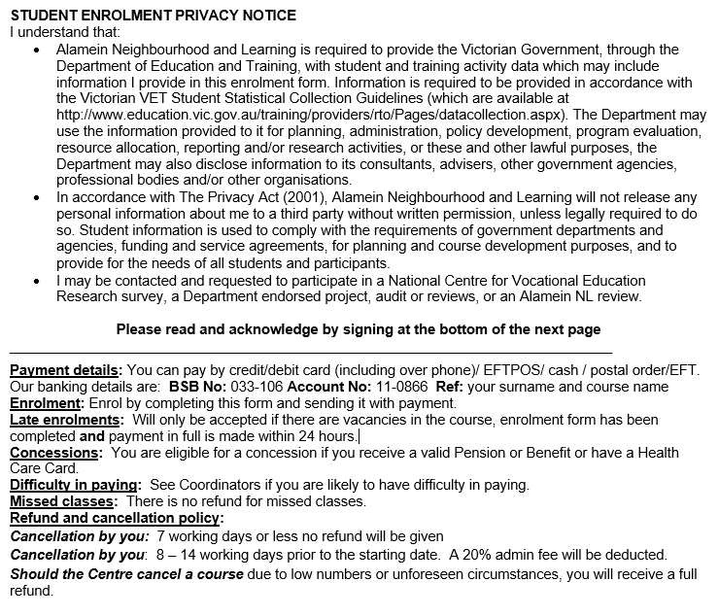

Please tick if you DO NOT want to receive information about ANL promotions & specials

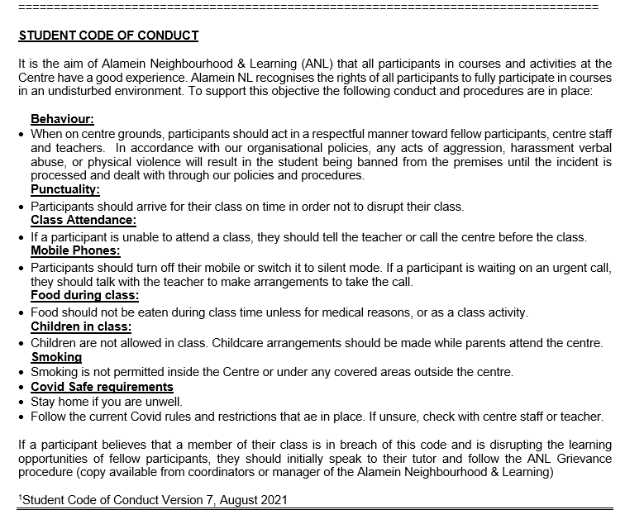

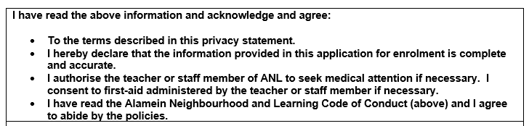
Full Name:

Signed: | Dated:

